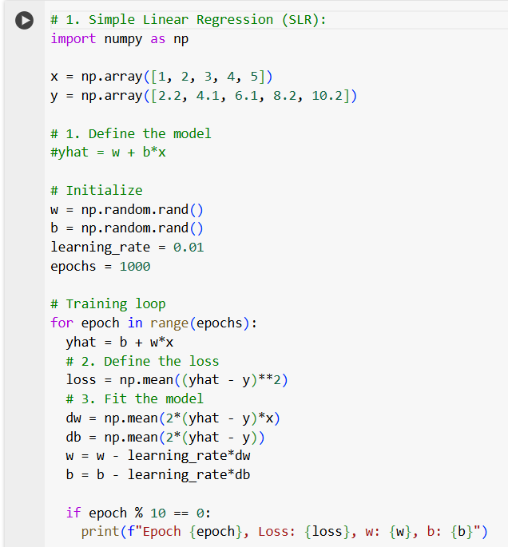**Simple Linear Regression (SLR)**

Formula :

y = w * x + b

- y is the predicted **output**

- x is the **input**

- w is the **weight** or **slope** of the line

- b is the **bias**

MSE = 1/N​i=1∑N​( y[i]​−yhat[i] ) ^ 2

- N is the number of data points.

- y[i] is the true value for the i-th data point.

- yhat[i] = w . x[i] + b is the predicted value for the i-th data point.

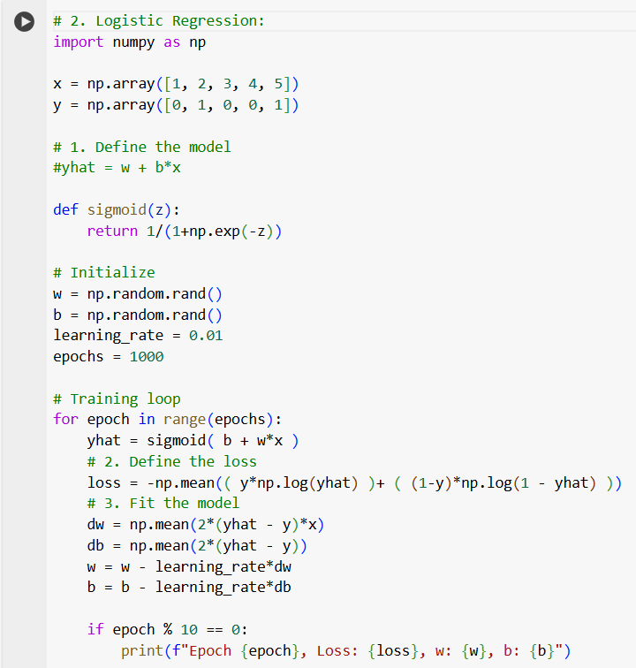**Logistic Regression:**

Compute a weighted sum of input features,

z = w * x + b, and apply the sigmoid function,

yhat = 1 / 1+e^−z. The model is trained using cross-entropy loss to minimize error.

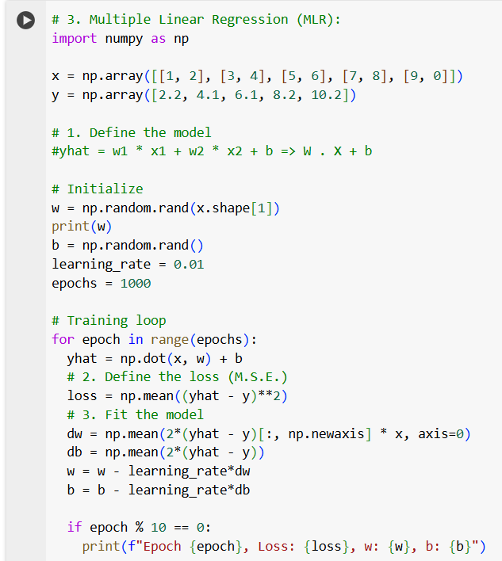**Multiple Linear Regression (MLR):**

MLR handles multiple input features by computing a weighted sum of all input features: yhat = w[1] * x[1] + w[2] * x[2]+...+ w[n] * x[n] + b